**Name :** Likhitha Chintareddy

**Andrew ID:** lchintar

**SCREAMING T-REX**

**Project Description :**

This is a game that’s similar to the T-Rex runner game in Google Chrome that one can play when there’s no internet available. However, instead of using the spacebar, the game will require audio input from microphone where the pitch, volume, and continuous vocalization will help the dinosaur jump and climb hills and clear various other obstacles.

**Competitive Analysis :**

The one project that’s extremely similar to the one that I’m planning currently is the Screaming Bird game made by Jae Pyung Park in Spring 2017. Screaming Bird game is actually the flappy bird game but uses voice volume to increase/decrease the height of the bird rather than the spacebar. It also has the option of using a spacebar if we choose to and the option of easy/medium/hard levels.

My project uses the same idea of using an audio property to change height. Instead, I’ll be using pitch to change the height and volume to hint at continuous vocalization. I intend to make my terrain uneven, with hills and cactuses. The dinosaur will have to jump over the cacti and has to run over the hills. As long as there’s an input volume of a certain range, the dinosaur will be able to climb up the hills or else it just moves back. I also intend to add more obstacles and Levels than the ones in Screaming Bird, instead of using the Easy/Medium/Hard options.

**Structural Plan :**

I intend to make multiple files with different functions in different files. Each obstacle will have a different file. There will be a function to draw the cacti, another function to check whether the sufficient volume peak has been reached to be able to climb up the hill, another function to create an obstacle that acts like a pitch threshold that the player must maintain in order to not die. A function will fire bullets and another function will keep track of the score. The code that finds the pitch using aubio and the volume will all be in the main file, however.

**Algorithmic Plan :**

The hardest part of my project, I believe, would be to use the pitch to turn it into height measurements. I using aubio to get the pitch in real-time and then I’m going to use the pitch to test using trial-error methods to put an upper limit to height, especially with regards to the threshold obstacle.

**Timeline Plan :**

I plan on sorting out the animation part of the project by the end of this week, and incorporating the height feature using aubiopitch (4/20). The next week, before TP2, I plan on adding at least one obstacle - especially the cacti. After TP2, by the end of the week (4/27), I plan on finishing most of the obstacles - the pitch threshold and the bullets. By the time of TP3, I plan on finishing adding final touches to the project like adding the start page and enhancing animation, or adding any other obstacle if I think of any in the meantime.

**Version Control Plan :**

I have automatic iCloud sync for all files on my Desktop and Documents which is where I’m currently storing my files. But I also made a folder in my Google Drive, titled 15-112 Term Project, where I keep updating the file after every change made. I plan on opening a github account too

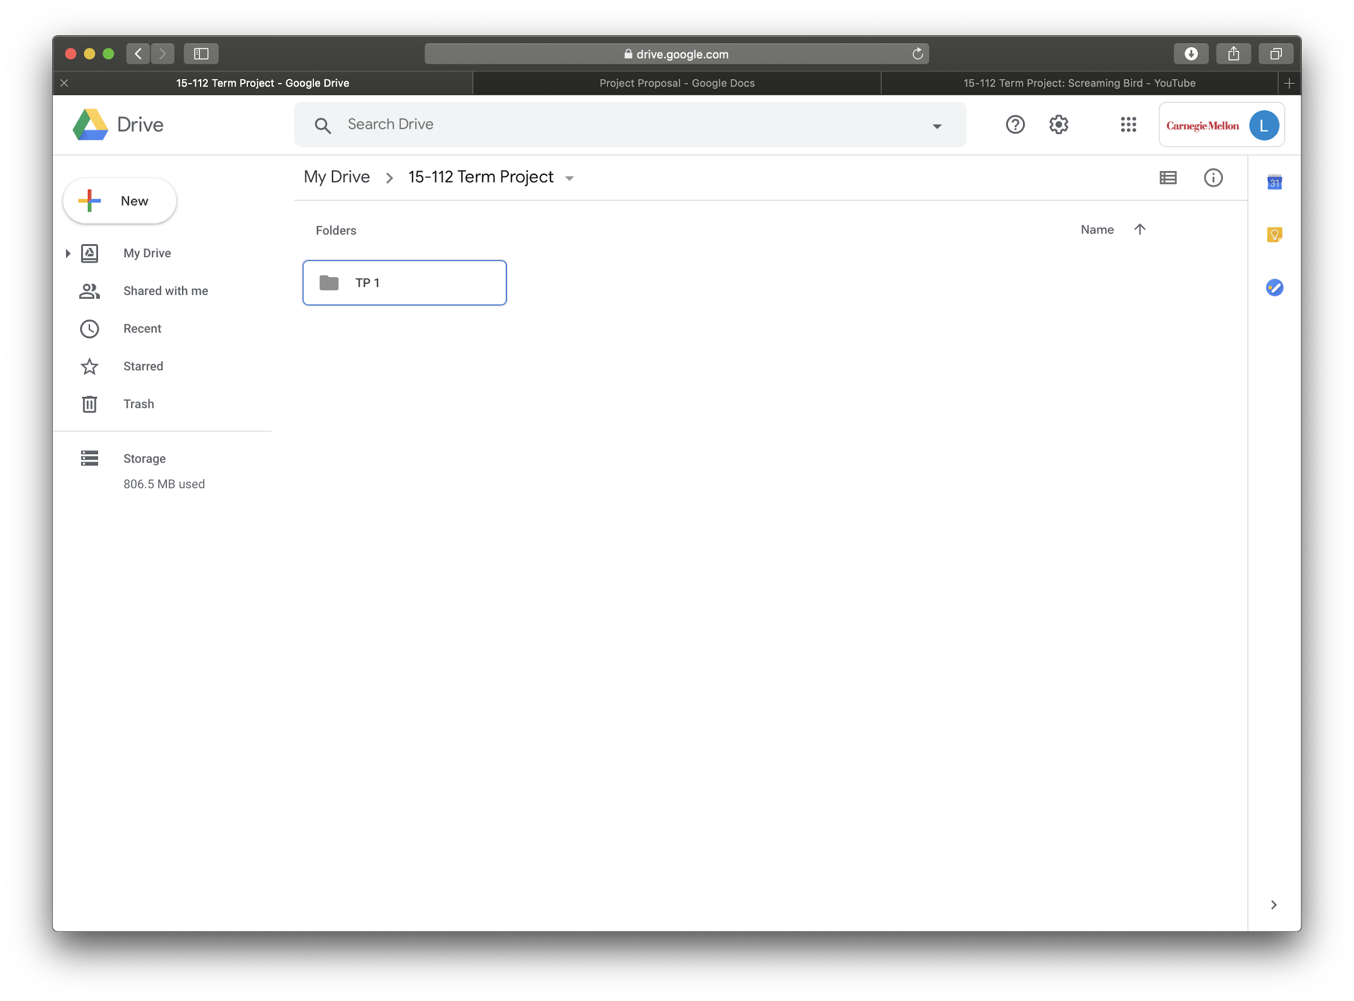

**Module List :**

I’m currently using the aubiopitch feature of aubio to be able to get the pitch of audiostream from the microphone in real-time

**TP2 Update :**

I’ve added a new feature which involves collecting deadly coins that end the game. I’m going to add more obstacles like falling cacti and hanging cacti which need to be avoided. And I’m also going to create birds which will fly towards the player and should also be avoided – all by variating the pitch and volume.

**TP3 Update :**

I’ve added a Night mode that automatically gets activated for an interval of 20 score points for every 30 score points. I’ve added a feature that records High score even when we close the terminal and end the game. I’ve added a Start screen and a screen that lets you choose the current character. I’ve also replaced the player character with different images for when flying or falling or gliding or dead.